Bridgnorth Town Council
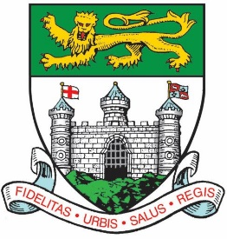
Bridgnorth Town Council is looking to recruit several full time and part time, permanent positions within their existing team.

The Town Council have high aspirations for the delivery of its services and working with its community and partners to deliver an exciting future for its residents, visitors and businesses that includes a project developing the High Street and refurbishment of the Town Hall.

Finance Officer  30 hours per week  Up to NJC SCP 11 - £25,979 per annum  (pro rata) |  | Business Administrator  37 hours per week  Up to NJC SCP 6 - £23,893 per annum
Property & Office Administrator
37 hours per week
Up to NJC SCP 5 - £23,500 per annum

All recruitment packs can be found on the Town Council’s website or by requesting a pack from the Town Council. Tel: 01746 762231 or Email: info@bridgnorthtowncouncil.gov.uk

