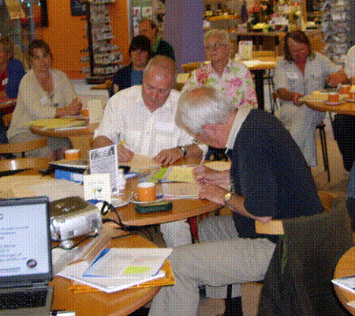
Budgets and Audit
Presented by:

(Derek Kemp and Melodie Beevers)
Wednesday 23rd November 2016 5pm – 7pm
Registration from 4.30pm

At Shirehall, Abbey Foregate, Shrewsbury SY2 6ND
Budgets

- Setting - Why? When? How?

- Legislation

- Explanation of supporting
statements



Audit
- Role of auditors - internal and external
- Understanding and actioning of an auditor report

- Timetable of events and dates

- Questions and Conclusion

PLEASE PLACE YOUR BOOKING THROUGH YOUR CLERK
Association of Local Councils, Shirehall, Abbey Foregate, Shrewsbury SY2 6ND
Tel. 01743 252744 email: alc@shropshire.gov.uk www.alcshropshire.co.uk

