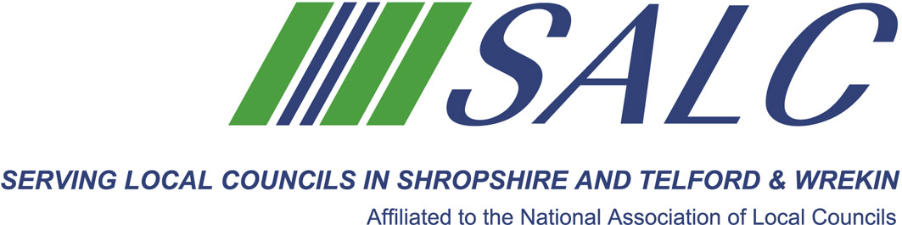

Business Planning Part 2 – Understanding Your Stakeholders
Friday 10th February 2017, 10.30am – 3.30pm
(Registration from 10am)
At Shirehall, Shrewsbury SY2 6ND
Presented by Lindsay Barton, Golden Kites Solutions Ltd.
Stakeholder engagement and management is key to the successful implementation of community and public services. Understanding those you work with and for helps to build strong relationships and,


Attendance: £60 per member delegate £85 per non-member delegate
PLEASE PLACE YOUR BOOKING THROUGH YOUR CLERK
SALC, Shirehall, Abbey Foregate, Shrewsbury SY2 6ND
Tel: 01743 252744 Email: alc@shropshire.gov.uk www.alcshropshire.co.uk
ultimately, to achieve your priorities for your communities. Understanding stakeholders and developing a strategy to manage stakeholders is an essential part within any organisation’s Business Plan.
During this interactive and practical learning session you will:
- understand why it is important to identify your stakeholders;
- learn how to identify them;
- explore what methods you could use to engage with different stakeholders;
- use some example best practice templates and tools.

Topics that will be covered are:
- What is a Stakeholder
- Stakeholder Identification
- Stakeholder Mapping and Analysis
- Engagement Methods

A WORKING LUNCH WILL BE PROVIDED

