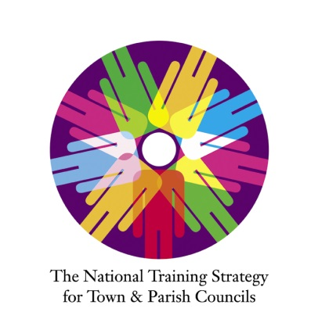
Record of Continuous Professional Development

Name:
Council:
Position:
Covering the period from:
To:

Topics headings and Key dates | What did you do? | What did you learn from this? | How have/will you use this?  How will your council change or improve? | Points allocated
Conferences and training events
Reading
Learning at Work
Developing the Sector

Total

All clerks whose councils seek a Local Council Award, are required to demonstrate that they have achieved at least 12 CPD points in the 12 months immediately preceding the council’s application for an award. For this there are some types of activity that carry a maximum point allowance per year. Plus, at least three points must come from a qualification, in-house assessment or a training event.

The grid below can help you assess how many points you have achieved and clearly illustrate this to the accreditation panel if you choose to apply for a Local Council Award.

 | Maximum points | Points achieved
Qualifications | 12
In-house assessment | 12
Learning at work | 6
Attendance at conferences and training events | 12
Reading and e-learning | 6
Developing the sector | 4
Total CPD points
At least three points have come from a qualification, in-house assessment or a training event?

