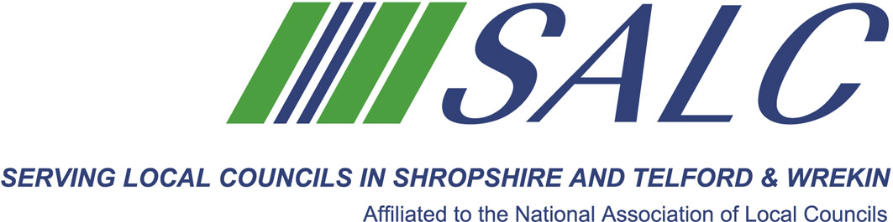

Presented by

John Skelton, Organisation Development Business Partner, Shropshire Council



The Event will focus on:
- Benefits of Appraisal Schemes
- Setting up a System at Your Council
- Getting the best from the process
- Appraisal forms
This event attracts One CPD point

Attendance: £25 per member delegate £100 per non-member delegate
PLEASE PLACE YOUR BOOKING THROUGH YOUR CLERK
Shropshire Association of Local Councils
Shirehall, Abbey Foregate, Shrewsbury SY2 6ND Tel: 01743 252744 Email: alc@shropshire.co.uk

Appraisals
Tuesday 24th April 2018, 5.30 pm – 7.30 pm (Registration from 5.30 pm)
Shirehall, Abbey Foregate, Shrewsbury SY2 6ND

The aim of this training session is to provide an overview of the appraisal process for both ‘managers’ and employees.
Clerks and their staff are key assets to councils and an Appraisal Scheme can improve their performance and encourage them to develop.

Please place your booking through your clerk. On-line booking form: www.alcshropshire.co.uk

Please use the main Shirehall Car Park

