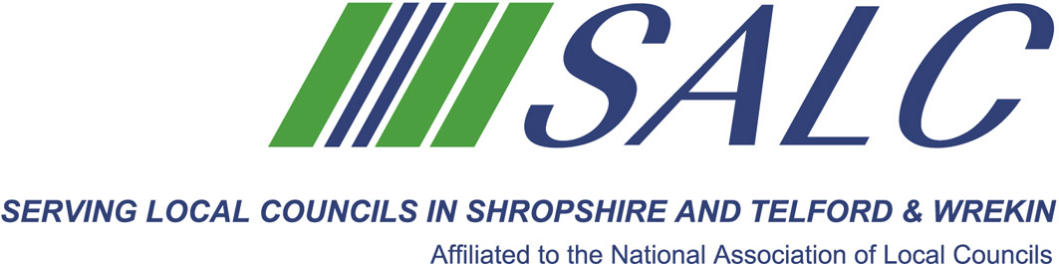

Presented by
Kim Bedford, FSLCC

The role of the Chairman as specified in law establishing the responsibilities and duties:
Preparing and chairing meetings /discussion/reporting and reaching a decision
Supporting and leading the team, developing skills and using experience
Handling conflict, styles of management and motivation
Strategy, budget, precept……delivery to the community
Plus an opportunity to network with colleagues and share experiences.
Who should come?
The training is aimed at experienced Councillors, especially those considering becoming the Chairman/Vice Chairman of their Council or Chairman of a Council Committee. Clerks are also welcome to attend.
Cost: £65 per member delegate £130 per non-member delegate
PLEASE PLACE YOUR BOOKING THROUGH YOUR CLERK
Shropshire Association of Local Councils, Shirehall, Abbey Foregate, Shrewsbury SY2 6ND
Tel: 01743 252744 Email: alc@shropshire.co.uk website: www.alcshropshire.co.uk

Chairmanship Skills
Friday 29th June 2018, 10.am – 4.pm (Registration from 9.30 am)
At Shirehall, Shrewsbury

Managing and leading people is one of the most challenging situations we find ourselves in. As a community leader you will explore:

