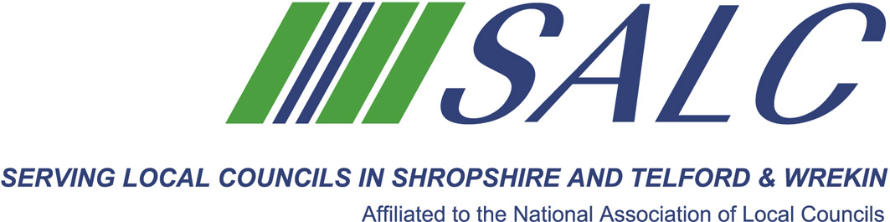

Presented by
Kim Bedford, FILCM
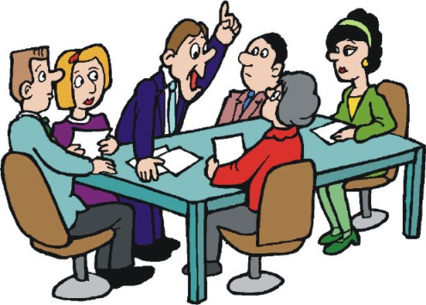

Who should come?
The training is aimed at experienced Councillors, especially those considering becoming the Chairman/Vice Chairman of their Council or Chairman of a Council Committee. Clerks are also welcome to attend.
What will it cover?
The role of the Chairman as specified in law establishing the responsibilities and duties:
• Preparing and chairing meetings
• Handling discussion/reporting and reaching a decision
• Chairing a challenging meeting
• Handling conflict
• Professional conduct
Plus an opportunity to network with colleagues and share experiences.

Cost: £25 per member delegate £100 per non-member delegate
PLEASE PLACE YOUR BOOKING THROUGH YOUR CLERK

Chairmanship Skills, Part 1
Monday 12th June 2017, 5.30pm – 7.30pm (Registration from 5pm)
At Shirehall, Shrewsbury

Managing and leading people is one of the most challenging situations we find ourselves in. As a community leader you will explore:

