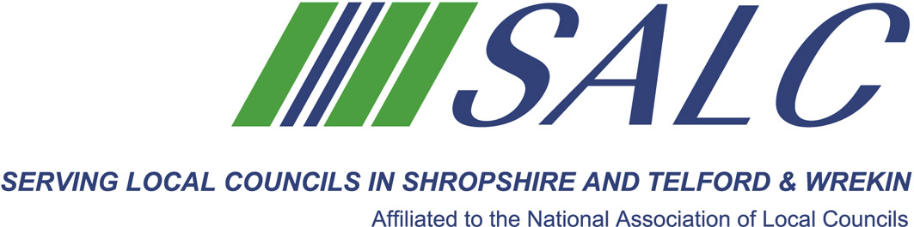

Presented by
Kim Bedford, FILCM



This is the last group session for students to have an opportunity ensuring they are conversant with what is required to complete their portfolio submission.

As before, all students will receive a brief prior to the session to aid their preparation.

Following lunch and time permitting, there is an opportunity for additional study time or networking with colleagues.

Attendance: £65 per member delegate £130 per non-member delegate
PLEASE PLACE YOUR BOOKING THROUGH YOUR CLERK

CiLCA Session 4
Friday 11th May 2018, 9.30am – 2.30pm
(Registration from 9am)
At Shirehall, Shrewsbury

The last in our CiLCA mentoring sessions will discuss what is required for Unit 5. Followed by a quick review of all learning outcomes and any issues arising from completed work before submission

