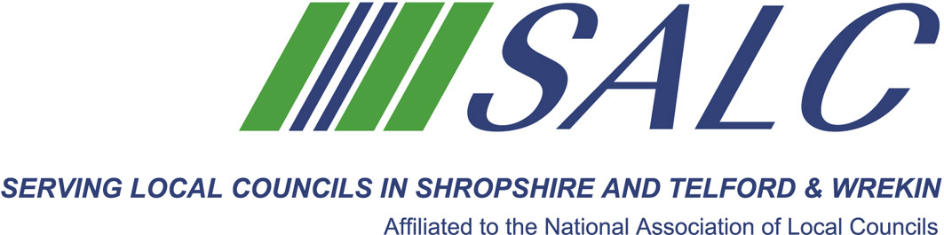

Presented by
Kim Bedford, FILCM



Students will be asked to prepare a short presentation on one of the Learning Outcomes to the group.

As before, all students will receive a brief prior to the session to aid their preparation.

Following lunch and time permitting, there is an opportunity for additional study time or networking with colleagues.

Attendance: £65 per member delegate £130 per non-member delegate
PLEASE PLACE YOUR BOOKING THROUGH YOUR CLERK

CiLCA session 4
Friday 9th June 2017, 9.30am – 2.30pm
(Registration from 9am)
At Shirehall, Shrewsbury

The last in our CiLCA 2015 mentoring sessions will spend time checking students understanding in submitting their portfolio and any issues arising from Modules four and five.

