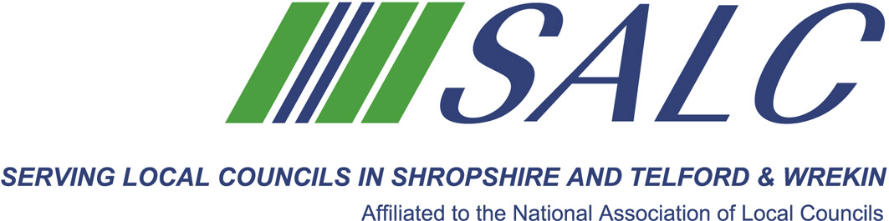
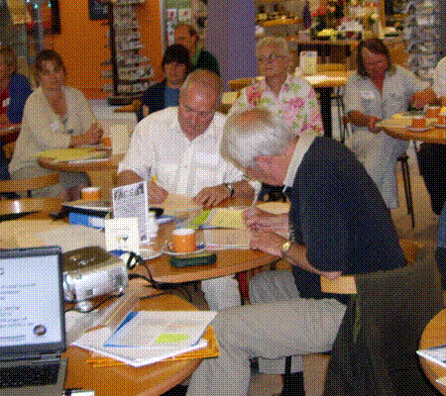

Presented by
Kim Bedford, FILCM


In this session we will re-cap from session one, dealing with any questions and issues which may have arisen from Module Two and Module Three.

The morning will continue, considering how we will approach Module Two, Law and Procedures.

All students will receive a brief in advance in order to prepare for the Tutorial.

A light lunch will be included in the cost of the training.
Cost: £60 per member delegate £85 per non-member delegate

PLEASE PLACE YOUR BOOKING THROUGH YOUR CLERK

CiLCA 2015 – Session 2
Friday 13th January 2017 9.30am – 2.30pm (Registration from 9am)
At Shirehall, Shrewsbury

