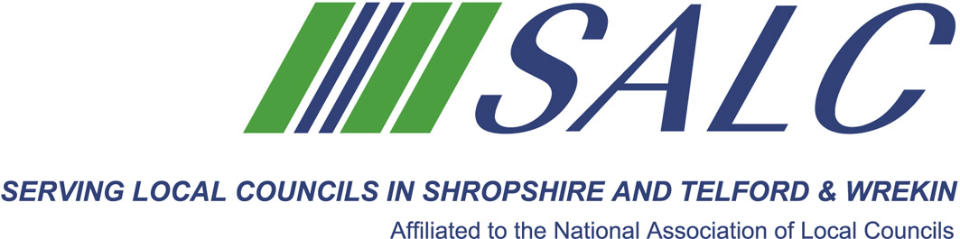
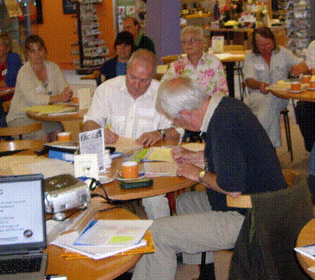

Presented by
Kim Bedford, FILCM

We will look in depth at the last two units:

Unit 4 Management for Local Councils
Unit 5 Community Engagement


We commence the day, reviewing work completed on Unit 2 before working through Learning Outcomes 21 to 30.

Time for further discussions over lunch, with the final hour being used to network, use reference books and to check aspects of your work with the tutor.

A light lunch will be provided.

Attendance: Member £60 per delegate Non-member £85 per delegate
PLEASE PLACE YOUR BOOKING THROUGH YOUR CLERK

CiLCA 2015 – Session 3
Friday 31st March 2017, 9.30am – 2.30pm (Registration from 9am)
At Shirehall, Shrewsbury

