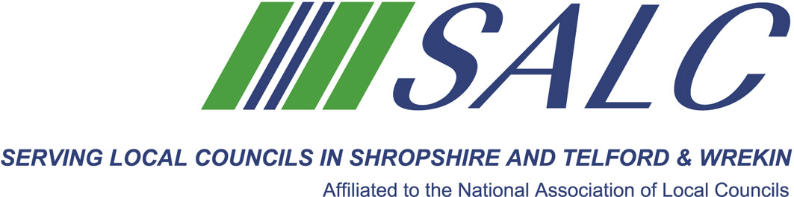
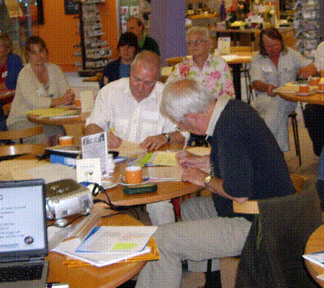

Presented by
Kim Bedford, FILCM

We will look in depth at two units:

Unit 3 Finance for Local Councils
Unit 4 Management for Local Councils


We commence the day, reviewing work completed on Unit 2 before working through Learning Outcomes 14 to 23.

Time for further discussions over lunch, with the final hour being used to network, use reference books and to check aspects of your work with the tutor.

A light lunch will be provided.

Attendance: Member £65 per delegate Non-member £130 per delegate
PLEASE PLACE YOUR BOOKING THROUGH YOUR CLERK

CiLCA – Session 3
Friday 23rd March 2018, 9.30am – 2.30pm (Registration from 9am)
At Shirehall, Shrewsbury

