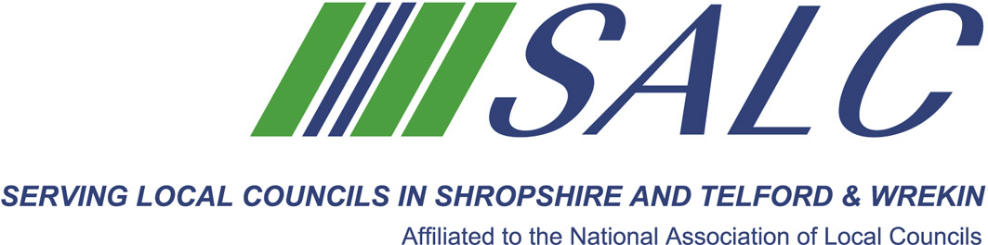
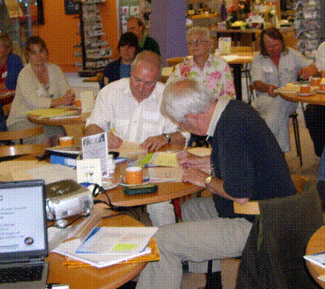
Briefing on Key Changes under
General Data Protection Regulations
With Robert Montgomery, Audit & Governance Team Leader
Telford and Wrekin Borough Council

Thursday 15th March 2018, 5.30pm – 7.30pm
At Shirehall, Abbey Foregate, Shrewsbury SY2 6ND
Registration, tea and coffee from 5pm

GDPR comes into
force on 25th May 2018

This session will cover:
- Provisions of the Legislation
- Key Changes
- Preparation and Compliance
- The Data Protection Officer

*INCLUDING LATEST UPDATES

Cost: £10 per member delegate £20 per non-member delegate

Shropshire Association of Local Councils, Shirehall, Abbey Foregate, Shrewsbury SY2 6ND
Tel: 01743 252744 Email: alc@shropshire.co.uk website: www.alcshropshire.co.uk

Parish Council Insurance
Does your Council have appropriate insurance cover? Do you know what should be insured?

