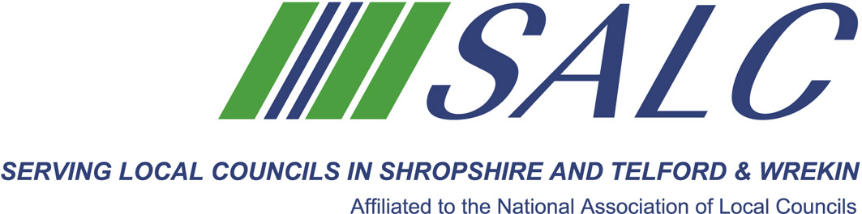
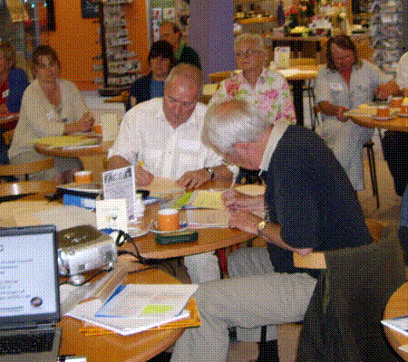
Briefing on Key Changes under
General Data Protection Regulations
With Robert Montgomery, Audit & Governance Team Leader
Telford and Wrekin Borough Council

Wednesday 8th November 2017, 5.30pm – 7.30pm
At Shirehall, Abbey Foregate, Shrewsbury SY2 6ND
Registration, tea and coffee from 5pm

GDPR comes into
force on 25th May 2018

This session will cover:
- Provisions of the Legislation
- Key Changes
- Preparation and Compliance
- The Data Protection Officer

Representatives from Shropshire and Telford & Wrekin Town and Parish Councils and the Voluntary Sector are invited to attend this FREE briefing but places are limited. If you wish to attend this briefing please reserve your place via our on-line booking form, located on our website: www.alcshropshire.co.uk

Shropshire Association of Local Councils, Shirehall, Abbey Foregate, Shrewsbury SY2 6ND
Tel: 01743 252744 Email: alc@shropshire.co.uk website: www.alcshropshire.co.uk

Parish Council Insurance
Does your Council have appropriate insurance cover? Do you know what should be insured?

