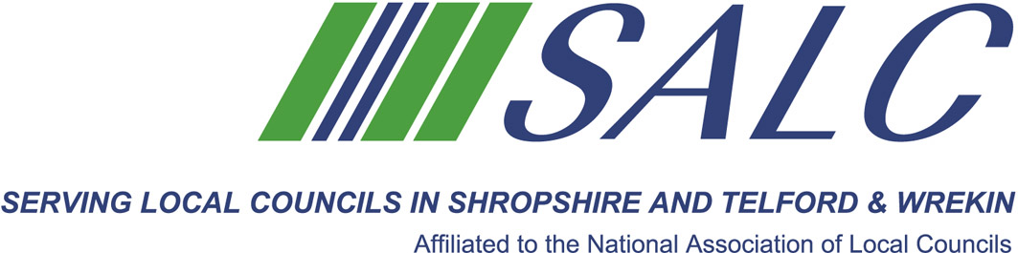

Presented by
Andrea Pellegram, MRTPI of Andrea Pellegram Ltd

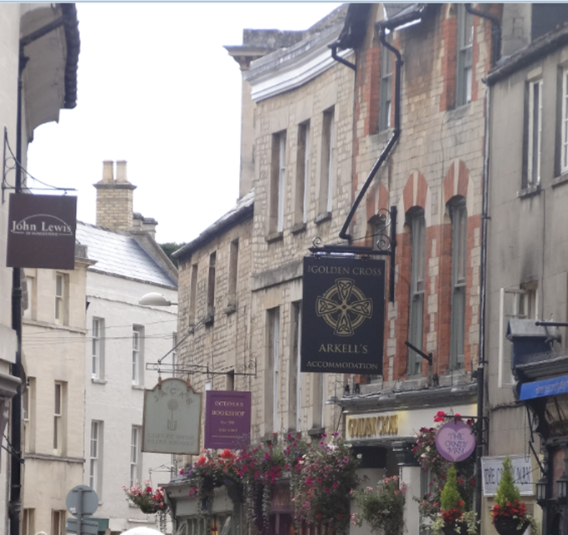erstand how motivationinfluence planning omes

evelop new skills to enable you to become more effective

Make new contacts

Become inspired to fight for your local community

Work towards NALC’s Local Council Award Scheme

Cost: member delegate - £65 non-member delegate: £130

PLEASE PLACE YOUR BOOKING THROUGH YOUR CLERK
on-line booking form located on our website www.alcshropshire.co.uk
Shirehall, Abbey Foregate, Shrewsbury SY2 6ND 01743 252744 alc@shropshire.co.uk

Cost: member delegate - £65 non-member delegate: £130

PLEASE PLACE YOUR BOOKING THROUGH YOUR CLERK
on-line booking form located on our website www.alcshropshire.co.uk
Shirehall, Abbey Foregate, Shrewsbury SY2 6ND 01743 252744 alc@shropshire.co.uk

Negotiate a Better Outcome in Planning
Wednesday 12th September 2018 10am – 4pm (Registration from 9.30am)
at The Lord Hill Hotel, Abbey Foregate, Shrewsbury SY2 6AX
Understand how motivations influence planning outcomes

Develop new skills to enable you to become more effective

Make new contacts

Become inspired to fight for your local community

Work towards NALC’s Local Council Award Scheme
Be SMART about Planning
Who should attend:
Town and Parish Clerks,
Mayors, members of the Planning Committee
and active citizens
Build your skills so that your next negotiation on a planning application yields results for your community.

Gain practical skills in speaking to developers and planners when seeking benefits for your community. Learn how to find a win/win position that will make developers want to provide new infrastructure as part of their major developments.
Training is delivered by Andrea Pellegram, MRTPI who has over 30 years’ experience in planning gained in community, district and county levels and the private sector.
A Light Lunch will will be provided.
Negotiate a Better Outcome
in PlanningD

