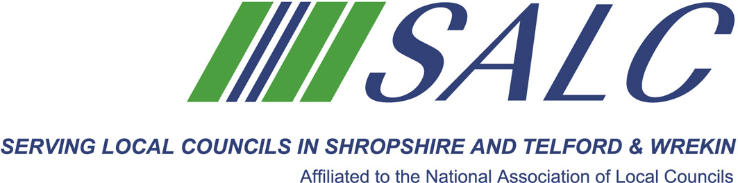

"If you want to know how the shoe fits, ask the person who is wearing it, not the one who made it."

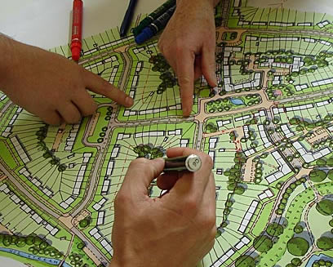

Cost per delegate: Member £65 Non-member £130

This event is FREE to delegates from member local councils.
Cost to delegates from non-member local councils - £100 per delegate.

PLEASE PLACE YOUR BOOKING THROUGH YOUR CLERK
Shropshie Association of Local Councils, Shirehall, Abbey Foregate, Shrewsbury SY2 6ND
Tel: 01743 252744 Email: alc@shropshire.gov.uk Website: www.alcshropshire.co.uk

Neighbourhood and Other Plans
Thursday 28th September 2017, 5.30pm – 7.30pm
At Shirehall, Shrewsbury

Over the past decades a wide range of community led planning tools and techniques have been pioneered. It is recognised that this is the only way that people will get the surroundings they want and it is now seen as the best way of ensuring that communities become safer, stronger, wealthier and more sustainable.

With 15 years experience of community planning Nicola Fisher of the Community Enablement Team at Shropshire Council will take us through the options, and give a straightforward view on what are the benefits, what is needed, what is available and how communities can use their plan to influence and benefit their community.
(Photo Attribution - Hands on planning
Woking Community Planning Weekend, 2007, John Thompson & Partners)
But how should it be done? How can local people, wherever they live, involve themselves in the complexities of architecture, planning and urban or rural design? How can communities influence the professionals and get them to build on local knowledge and resources? In this session, we will review current Community Led Planning options, everything from Parish Plans to Neighbourhood Plans and we will explore which option is most appropriate for your community. How does the latest Shropshire Council Local Plan Review affect your decision on which route to take?

