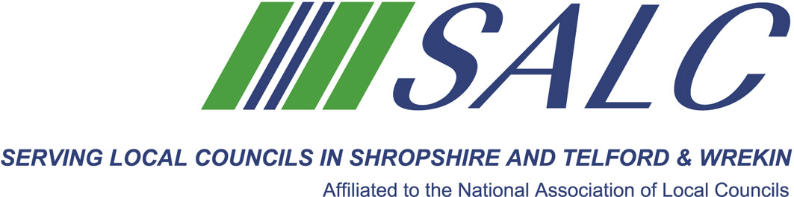

Presented by
Andrea Pellegram of Andrea Pellegram Ltd

Part two: Forward planning and looking to the future
It’s a plan led system!
The development plan
The stages in local plan preparation
Parish and Town Council plans
LUNCH BREAK – a light lunch will be provided

Part three: Development management
How development management works in principle
The planning officer’s role
Planning committee
Planning enforcement
Types of planning application
How to comment on a planning application

Part four: Important planning concepts
Community Infrastructure Levy
Planning Conditions
Planning Obligations (S. 106)
Viability
Housing land supply
Cost: member delegate - £65 non-member delegate: £130

PLEASE PLACE YOUR BOOKING THROUGH YOUR CLERK
on-line booking form located on our website www.alcshropshire.co.uk
Shirehall, Abbey Foregate, Shrewsbury SY2 6ND 01743 252744 alc@shropshire.co.uk

Planning from a Local Council Perspective
Wednesday 7th June 2017 10am – 4.30pm (Registration from 9.30am)
at The Lord Hill Hotel, Abbey Foregate, Shrewsbury SY2 6AX
Session overview:

Part one: Nuts and bolts
Key stakeholders and their nterests

The role of the local council

