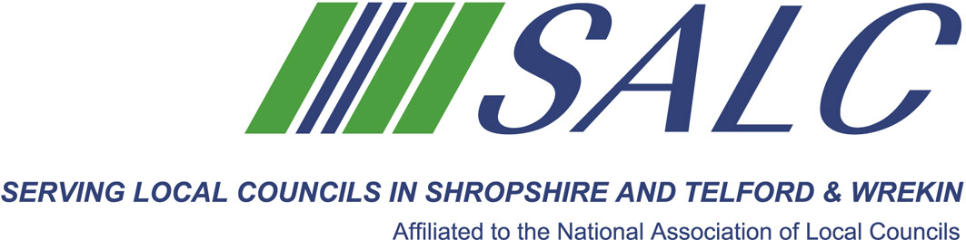

Presented by
Gordon Fong, e-mango



We know councils always have a concern on how it is used and the kind of engagement with users it entails, good and bad.

This is also a forum for people to express and share their thoughts, and collectively we can try and address those concerns. Whilst this is part presentation, it is really about getting everyone to participate in the discussions.

Session benefits:
- Be comfortable with the concepts of Social Media
- Understand the terminology, roles and interactions
- See the basics of Social Media in action, focussing on Facebook
and Twitter
- Have confidence in taking the next steps, if only small ones

Cost: member delegate - £25 non-member delegate: £100

PLEASE PLACE YOUR BOOKING THROUGH YOUR CLERK
on-line booking form located on our website www.alcshropshire.co.uk

Shirehall, Abbey Foregate, Shrewsbury SY2 6ND 01743 252744 alc@shropshire.co.uk

Social Media
Monday 5th June 2017 2pm – 4pm (Registration from 1.30pm)
At Shirehall, Shrewsbury

Session overview:

This session is designed to give participants a very general and gentle introduction into what is social media, why use social media, and how to use social media.

