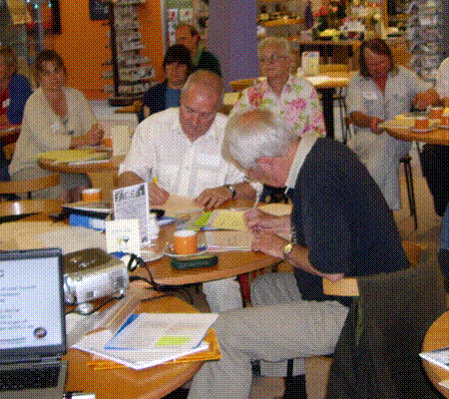
VAT for Town and Parish Councils
Presented by:
(Derek Kemp and Melodie Beevers)

When: Monday 16th October 2017 2pm – 4.30pm, registration from 2pm

Where: In the Council Chamber, at Shirehall, Shrewsbury SY2 6ND

Clerks, are you aware of VAT and it’s implications on your council’s activities now and on any future plans? Did you know it is now always possible to reclaim VAT?

This training will provide a general overview and will include:

- VAT registration - should you, must you, how you are affected if you don’t

- Procedures for reclaiming VAT

- VAT partial exemption calculations

- VAT on major projects

- Question time

Cost per delegate: member £25 Non-member £100

Association of Local Councils, Shirehall, Abbey Foregate, Shrewsbury SY2 6ND
Tel. 01743 252744 email: alc@shropshire.gov.uk www.2shrop.net/alc

