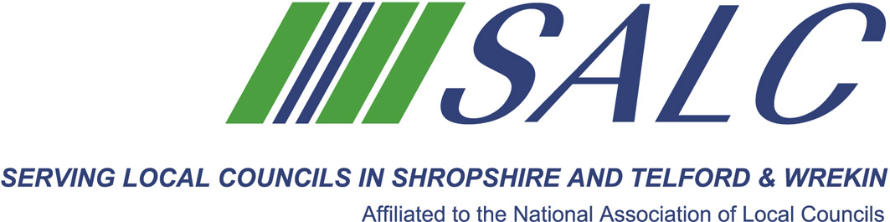

Presented by
Gwilym J. Rippon, Member ILCM, Cert HE Ceg

Overview:
Agendas are the key tool for a successful meeting and minutes are a requirement at all local council meetings. This interactive one day training course is designed for anyone who would like to acquire or improve their skills, knowledge and understanding of working effectively in meetings.
Why should you attend:
- Recognise how best to prepare both agendas and minutes.
- Consider the best style and variations in content for agendas.
- Find out how to practice your skills of listening, note taking and writing.
- Understand the formalities and legal duties of minute taking, logging and signing.
Who should attend?
- New clerks
- Deputies, committee managers and aspiring administration assistants.
- Current clerks looking to refine their meeting skills or to acquire new techniques to further increase their effectiveness at meetings
Course outline:
- What are agendas and minutes?
- Good and bad examples.
- How to lead a great meeting?
- Exercises
Trainer:
Gwilym Rippon is a Town Clerk to Kington Town Council in Herefordshire, a clerk to 2 small Parish Councils in Shropshire Bettws y Crwyn and Newcastle and a clerk to a Community Council in Powys, Abermule (with) Llandyssil Community Council. Previously a Police Officer for 33 years he came into the sector by accident but now thoroughly enjoys the work. Gwilym is the only clerk that holds CiLCA England and Wales qualifications, has attended the University of Gloucestershire and has attained a Certificate of Higher Education in Community Engagement and Governance. He wears several hats of the society, those being. Trainer for Wales, Employment support Officer and Deputy Advisor for Wales. He has been elected by Powys Branch to sit on the NEC ( National Executive Council) for the SLCC. At the time of writing Gwilym is also a board member of the ILCM (Institute of Local Council Management) and is a member of the Institute. Gwilym is also a member of the IIMC (International Institute of Municipal Clerks) and attended his first internal conference in Brussels in June 2014. Currently he is the Chair of the Hereford branch of the SLCC.

Attendance: £22 per member delegate £55 per non-member delegate
PLEASE PLACE YOUR BOOKING THROUGH YOUR CLERK

Agendas and Minute Taking
Wednesday 31st August 2016, 2pm – 5pm
(Registration from 1.30pm)
At Shirehall, Shrewsbury

