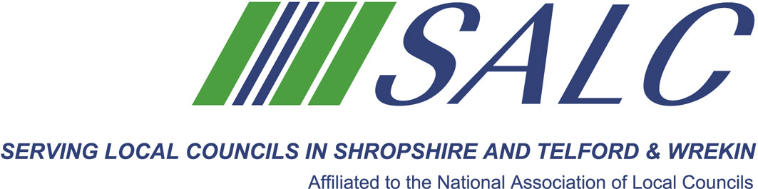


Presented by
Kim Bedford, FILCM


A training course for Clerks and Responsible Financial Officers

A training session looking at the statutory requirements in these changing times . Topics covered will include –

- Working on appropriate time frames to comply with the reporting requirements
- Understanding the responsibilities of both the Clerk/RFO and the Council
- Current assurance audits
- What is needed in completing the Annual Return
- Transparency requirements
- Future changes and their implications
- Sources of advice and guidance

The course will also give Clerks/RFOs the opportunity to compare and contrast their approach to audit and discuss the positives and the negatives.

Cost: £22 per member delegate £55 per non-member delegate
PLEASE PLACE YOUR BOOKING THROUGH YOUR CLERK

Shirehall, Abbey Foregate, Shrewsbury SY2 6ND
Tel. 01743 252744 Email: alc@shropshire.gov.uk www.alcshropshire.co.uk

Audit/End of Year Preparation
Friday 17th March 2017 2pm – 5pm (Registration from 1.30pm)
At Shirehall, Shrewsbury

