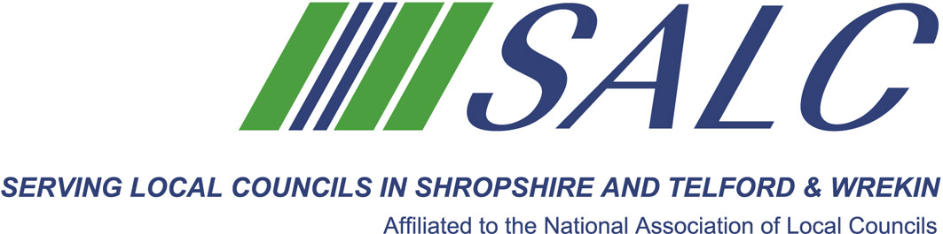

Presented by
Kim Bedford, FILCM
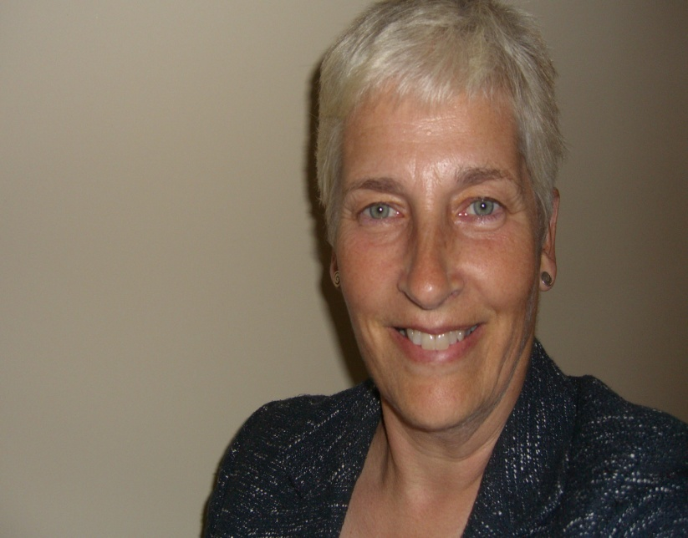

- creating the Council’s forward plan / strategy
- How do you harness skills and experience in order to form a council’s vision?
- How do you ensure the team are able to deliver the projects for the community?
- What ways can we use to communicate, be inclusive and enhance life for all in our areas?
- Lastly, the process of strategy, budget and precept setting

Cost: £25 per member delegate £100 per non-member delegate
PLEASE PLACE YOUR BOOKING THROUGH YOUR CLERK

Shirehall, Abbey Foregate, Shrewsbury SY2 6ND
Tel. 01743 252744 Email: alc@shropshire.gov.uk www.alcshropshire.co.uk

Chairmanship Skills – Part 2
Thursday 7th September 2017, 5pm – 7pm
(Registration from 4.30pm)
At Shirehall, Shrewsbury

In the second of our Chairmanship Skills sessions we will examine building a team, with the aim of:

