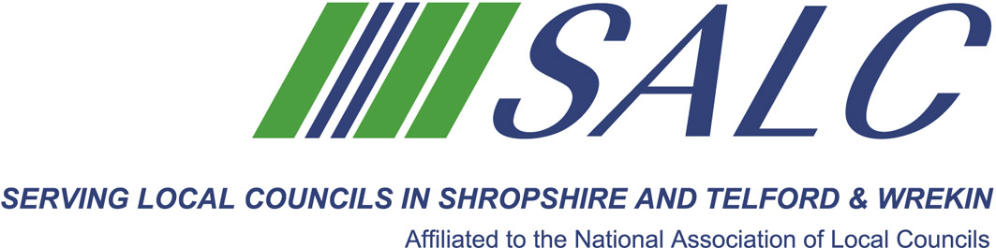

Presented by
Kim Bedford, FILCM


This training is intended for those who have missed the opportunity for the full Session 1. We will start with a brief introduction to study, looking at time management, what is required, and looking at obstacles to study. Followed by a whistle-stop review, of each learning outcome in Module One of the guide.
Attendance: £40 per member delegate £65 per non-member delegate
PLEASE PLACE YOUR BOOKING THROUGH YOUR CLERK

CiLCA 2015 Session 1
Friday 31st March 2017, 2.30pm – 5.30pm
Shirehall, Abbey Foregate, Shrewsbury SY2 6ND

