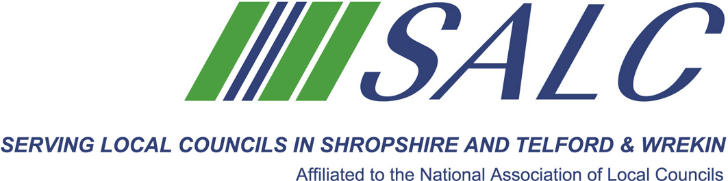

Presented by
Kim Bedford, FILCM



This training event, the first of 4 mentoring support days, is led by Kim Bedford. You will:
- receive tips on how to submit your portfolio
- learn about the requirments for completing the course
- learn where to find the information
- review the tasks that have to be completed for Unit One
- enjoy the support of your fellow students

The role of the Proper Officer - the Clerk to the Council, is a profession and this is YOUR OPPORTUNITY to become CiLCA qualified.
A Light Lunch will be provided.
Attendance: £65 per member delegate £130 per non-member delegate
PLEASE PLACE YOUR BOOKING THROUGH YOUR CLERK
Shropshire Association of Local Councils
Shirehall, Abbey Foregate, Shrewsbury SY2 6ND Tel: 01743 252744 Email: alc@shropshire.co.uk

CiLCA Session 1
Friday 3rd November 2017, 9.30am – 1.30pm (Registration from 9am)
Shirehall, Abbey Foregate, Shrewsbury SY2 6ND
(in the Executive Dining Rooms)

CiLCA, the Certificate in Local Council Administration, is a level 3 qualification, tailored to the role of Clerk to the council.

To book your place go to the SALC website and book on-line www.alcshropshire.co.uk

