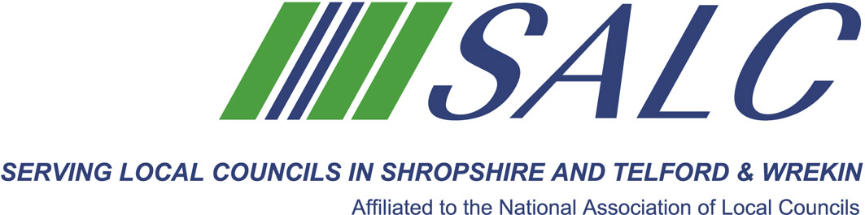
Shropshire Elections 4 May 2017
Clerks…All You Need to Know
With Stacey Ijewsky, Electoral Service Manager, Shropshire Council
and SALC
Friday 17th February 2017, 9.30am – 12.30pm
(Registration from 9am)
At Shirehall, Shrewsbury

- All You Need to Know Guide to Elections and Casual Vacancies

- Declaration of results – what to have prepared

- Co-option process if there are not enough councillors to fill seats

- Bring your councillors up to speed

E
L
E
C
T
I
O
N
S
E
L
E
C
T
I
O
N
S

Attendance: £22 per member delegate £55 per non-member delegate

PLEASE PLACE YOUR BOOKING THROUGH YOUR CLERK

SALC, Shirehall, Abbey Foregate, Shrewsbury SY2 6ND
Tel. 01743 252744; email: alc@shropshire.gov.uk; www.alcshropshire.gov.uk

