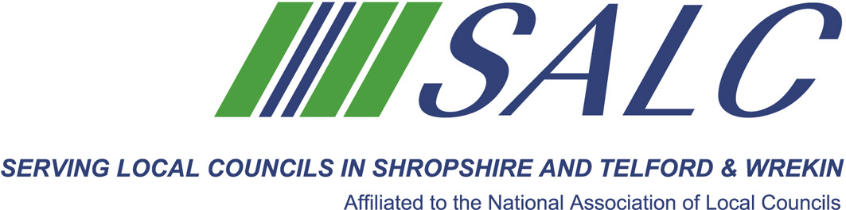

Presented by
Lindsay Barton, Golden Kite Solutions Ltd.

Managing time isn’t about squeezing as many tasks into your day as possible. It’s about simplifying how you work, prioritising tasks, doing things faster, and relieving stress. During this session you will learn how to use effective personal time management to achieve goals, supported by easy to use methods and know how to recognise and manage stress in the workplace.

Topics that will be covered are:
- Importance of effective time management
- Identifying your strengths and weaknesses in time management
- Setting and prioritising objectives
- Time management techniques
- Managing workplace stress

The old adage “Work smarter not harder” does work!

Attendance: £22 per member delegate £55 per non-member delegate
PLEASE PLACE YOUR BOOKING THROUGH YOUR CLERK
Shirehall, Abbey Foregate, Shrewsbury SY2 6ND
tel. 01743 252744, email alc@shropshire.gov.uk, www.alcshropshire.co.uk

Managing Yourself (effective time management)
Monday 27th February 2017, 2pm – 5pm
(Registration from 1.30pm)
Shirehall, Abbey Foregate, Shrewsbury SY2 6ND



