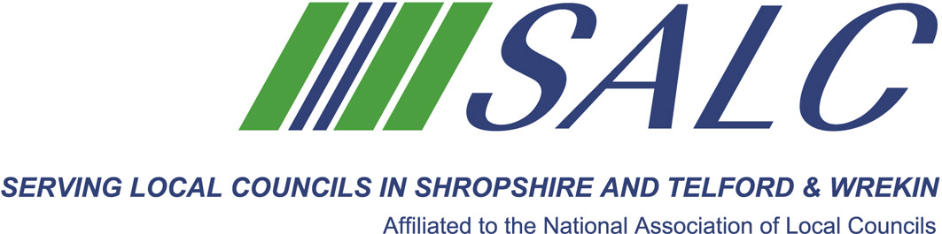

Shropshire Association of Local Councils
Annual General Meeting & Conference
Friday 9th November 2018

Nominations for Honorary Officers
Please complete this form and return to SALC, Shirehall, Abbey Foregate, Shrewsbury SY2 6ND, to be received no later than Friday 2nd November, 2018.

The following Honorary Officers were elected at the last AGM:

Position | Existing Officer | Nomination
President | Vacancy
Vice Presidents.  Mrs P Dee, Mr E Humphries, Mr C Mellings and Mrs M Shineton | Mrs P Dee
 | Mr E Humphries
 | Mr C Mellings
 | Mrs M Shineton
Honorary Auditor | Shropshire Council

This nomination form is submitted by:

…………………………………………………………………………………………
Parish/Town Council

