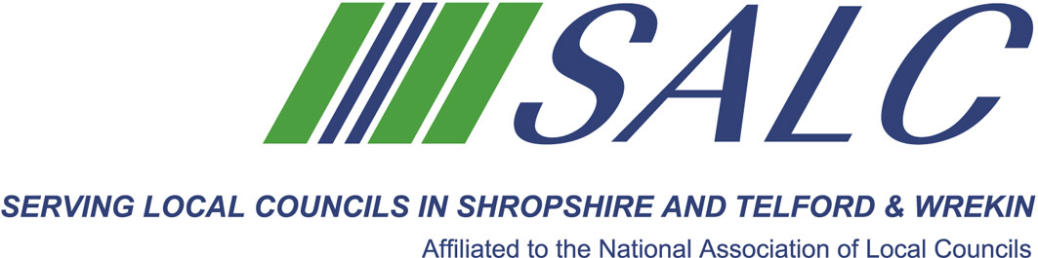

Introduction to Business Planning – Top Ten Tips
Friday 2nd December 2016, 10.30am – 1pm (Registration from 10am)
At Shirehall, Shrewsbury
Presented by Lindsay Barton, Golden Kites Solutions Ltd.
To achieve high standards, you have to evolve, react quickly to changes and be better than the alternative. This necessitates change, trying something new. This can be overwhelming, especially if you are a smaller parish council or a voluntary organisation not used to competing for business. If you feel it’s too difficult, think again. Break it down into smaller pieces.


A Business Plan IS essential and during this interactive and shared learning session you will be given an insight into good business planning and effective ways to approach and deliver what you want to achieve for your communities.

Topics that will be covered are:
- What is a Business Plan
- Focusing on what matters
- Creative thinking
- Community engagement and stakeholders
- Vision and Priority setting
- SWOT analysis
- Action Planning

This is an opportunity for you to learn the key stages required to create your Business Plan and make positive steps forward for your communities.

Attendance: £22 per member delegate £55 per non-member delegate
PLEASE PLACE YOUR BOOKING THROUGH YOUR CLERK
SALC, Shirehall, Abbey Foregate, Shrewsbury SY2 6ND
Tel: 01743 252744 Email: alc@shropshire.gov.uk www.alcshropshire.gov.uk

