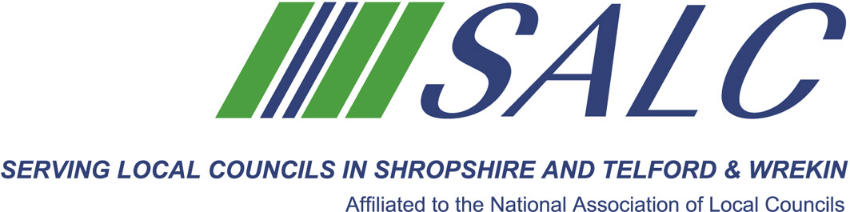

JAN SNELL AWARD 2018

This is awarded to a Town or Parish Council who has in the last 12 months accomplished a significant improvement for their local community.

Do you feel your Town or Parish Council has achieved something extra special this year?

Have you achieved Local Council Award Scheme Status?

Provided an extra service for your Parishioners?

Have you worked in partnership in any particular project e.g. rebuilding your Village Hall?

Or is there anything else that you feel your Town or Parish Council deserves to be recognised for in 2018?

Please forward applications for this prestigious award to SALC, Shirehall, Abbey Foregate, Shrewsbury SY2 6ND, to be received no later than Friday 26th October. This Award will be presented at the AGM on 9th November.
………………………………………………………………

Name of Parish Council…………………………………………………………...............
Contact person name ………………………………………………………………………….
Telephone number.………………………………………………………………………………
Brief outline of your project………………………………………………………………..................
………………………………………………………………………………………………...........
……………………………………………………………………………………………………………………………………………………………………………………………….........................
………………………………………………………………………………………………………………………………………………………………………………………………………………………………………………………………………………………………………………………………
Continue on additional page if necessary………………………………………….

