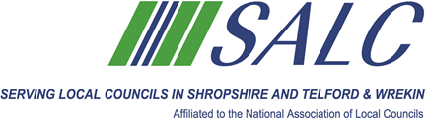

Calling all

Long Standing Officers

How long have you been working as a Clerk/Officer

If you have been a Parish/Town Clerk for 25 years or longer, not necessarily to the same Council, we would like to hear from you.

At our AGM on 9th November, 2018 any Clerk who has served for 25 years or longer will be presented with a Service Certificate.

Please fill in the details below and return to:-
SALC, Shirehall, Abbey Foregate, Shrewsbury SY2 6ND, to be received no later than Friday 26 October.
……………………………..
Name of Officer/Clerk | Name of Current Council | Contact Details | Are you attending the AGM Yes/No | No of years Service

