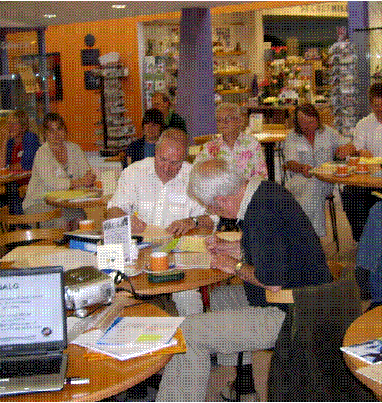
VAT for Town and Parish Councils
Presented by:

(Derek Kemp and Melodie Beevers)

When: Wednesday 14th September 2016 5.30 – 7.30pm, coffee and registration
from 5.00pm

Where: In the Wilfred Owen Room at the Shirehall, Shrewsbury

- What you thought you knew about VAT

- VAT Registration
VAT on income
Business and Non-Business Activities
VAT on expenditure

- Procedures for claiming VAT

- VAT on Major Projects

- Option to Tax Buildings
Advantages and disadvantages

- VAT Partial Exemption
Why, when and how

- Question and Answer Session
Please place your booking through your clerk

Association of Local Councils, Shirehall, Abbey Foregate, Shrewsbury SY2 6ND
Tel. 01743 252744 email: alc@shropshire.gov.uk www.2shrop.net/alc

